
Storage Tank Type Water Heater
Gas Fired or Electric Type - Heat Pump

Community Development – Building Division
Telephone number (650) 259-2330

What permits do I need to replace an existing storage water heater.
A plumbing permit is required to the installation, alteration, repair, relocation, replacement, of water heaters within the City of Millbrae as regulated the California Plumbing Code.

To Obtain a Plumbing Permit
An application for a plumbing permit is required to be filed online with the building division through the City of Millbrae web page building permit portal at:
https://millbrae.ca.eprocess360.com

Installation requirements of new or replacement gas fired water heaters.
Water heater installed in residential garages and in adjacent spaces that open to the garage and are not part of the living space of a dwelling unit shall be installed so that all burners and burner-ignition devices are located not less than 18 inches above the floor unless listed as flammable vapor ignition resistant (FVIR).

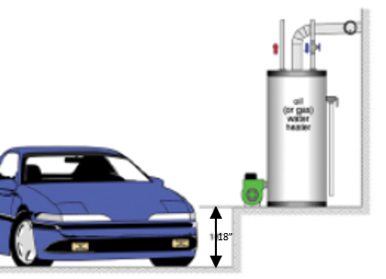

Electric Type – Heat Pump Water Heater
Replacing a gas fired water heater to an electric or heat pump type water heating system, an electric load calculation shall be provided to justify that the existing main service panel if less than 125 amperes is capable sustaining the additional electric current.
The required single – or 3 phase branch circuit for the electric – heat pump water heater shall be provided with a Class “A” GFCI protection for personnel.
A separate electrical permit will be required.

Seismic Provisions.
All new and replacement water heaters, and all existing residential water heaters shall be braced, anchored, or strapped to resist falling or horizontal displacement due to earthquake motion.
Strapping shall be at points within the upper one third (1/3) and lower one-third (1/3) of its vertical dimensions. At the lower point, a minimum distance of four (4) inches) shall be maintained above the controls with the strapping.
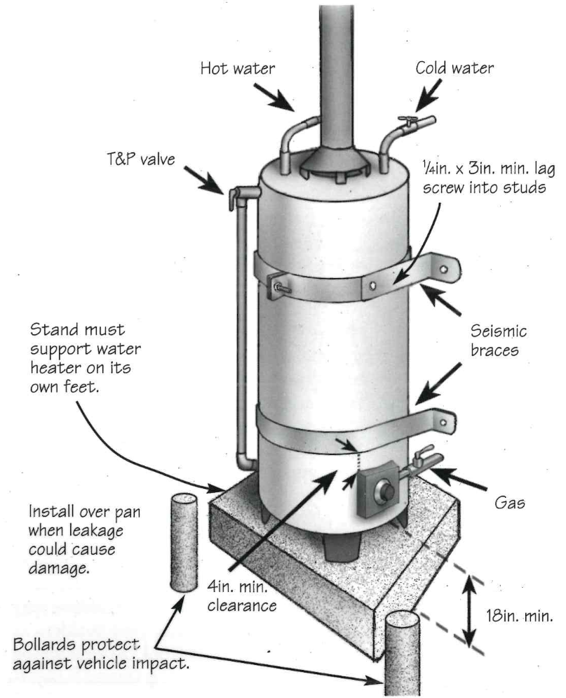
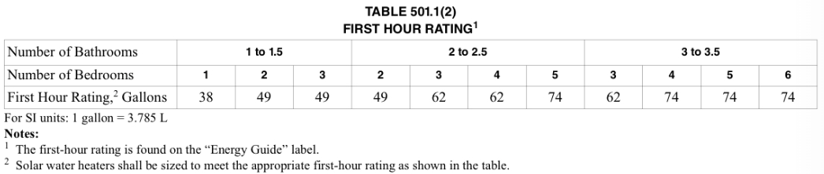
California Energy Code.
All domestic hot water piping shall be insulated in the first 5 feet of hot and cold water pipes from the storage tank or water heater.

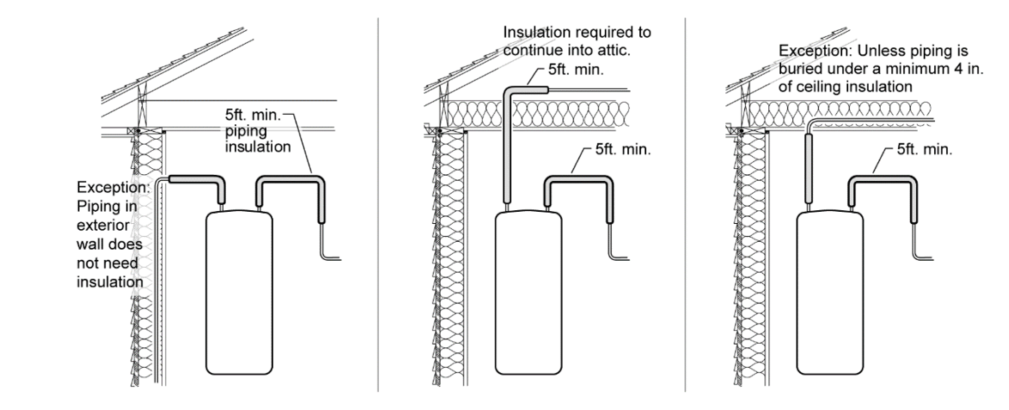

The California Energy Code requires that all water heaters including instantaneous water heater aligns with the minimum Federal Uniform Efficiency Factor.
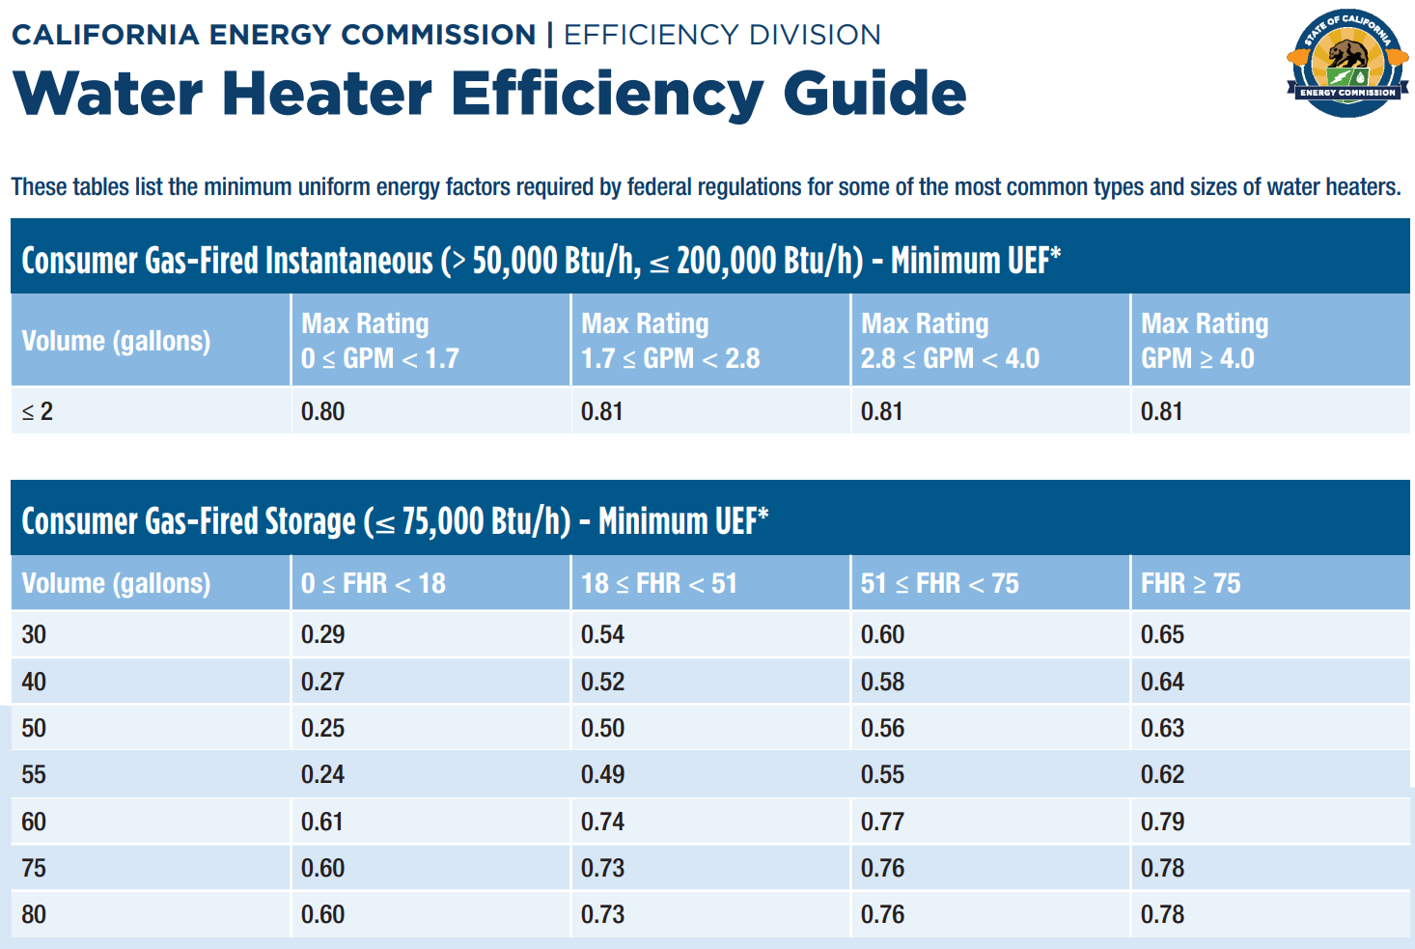
FHR – First Hour Rating
UEF – Uniform Energy Factor

Temperature and pressure relief valves
The temperature and pressure relief valve is installed in order to help relieve pressure from your water heater. If your water heater gets too hot, steam and pressure can start to build up and if it isn’t let out there could be a potential explosion. This valve helps to keep your family safe by reducing the pressure.
A temperature and pressure relief valve connected to a drain line which extends to the exterior of the building, points downward, and discharges between 6 and 24 inches above grade is required. If you cannot drain to the outside, other locations for termination may be approved. The drain line must be 3/4” minimum, and the end cannot be threaded.
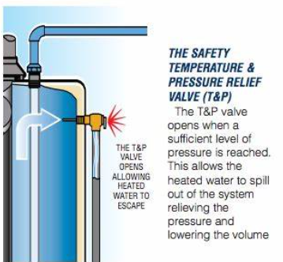

INSPECTIONS
Usually only one inspection is needed after the water heater has been installed and all work is completed.
If new gas piping is installed, the piping will require a 10 psi of air pressure test and must hold for ten minutes with no drop in pressure. Use a test gauge with 1/10 lb.
Maintenance of Instantaneous Water Heaters.
The primary maintenance activities for water heaters are flushing the heat exchanger to remove scale buildup and inspecting and cleaning the inlet water filter screen, which helps minimize the amount of debris or sediment that enters the water heater.

